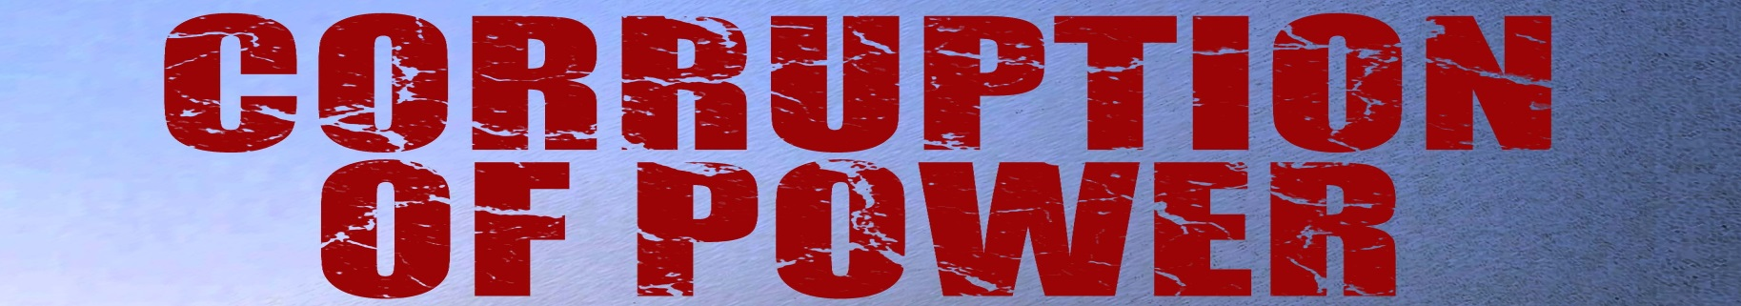
Corruption of Power newsletter |  | Issue: 4 | May 2016
“This a terrific thriller beautifully paced as it gets faster and more furious in the final third of the book. I give it five stars.” (Temple Emmet Williams, Former Editor, The Reader’s Digest)

“An up-to-the-minute compelling thriller that combines political sophistication with traditional gore and glory.”
(Ray Snoddy, former media editor of The Times and Financial Times and BBC presenter)

Recent Recognition & Awards for CoP    Awesome Indies Book Review  Corruption of Power by G.W. Eccles initially unfolds like a Russian classic of old. The mood is dark. The characters are difficult to grasp. There is a whole lot of stoic Russian angst. Woven within the pages are a deep concern for the arts and the psychology of man.  But, you will fall in love with this novel in the first chapter and will be powerless to put it down. Corruption of Power tells a tale of suspense and intrigue, focusing on all too real current events. As excitement builds, the characters quickly become three dimensional, complicated people with whom we can identify. Flashbacks and backstory are there when needed, written with natural consequence through the use of an object or a thought to spark memories. Each chapter leaves the reader wanting more, yearning to see what happens next.  Corruption of Power is an incredible reading experience. It is a well written page turner that will appeal to lovers of mystery / suspense / thriller genres.  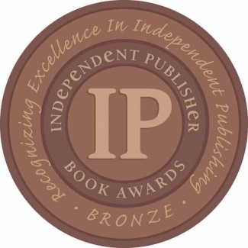  Medal winner in Best Mystery Thriller e-book category at Independent Publishers Book Awards |  | 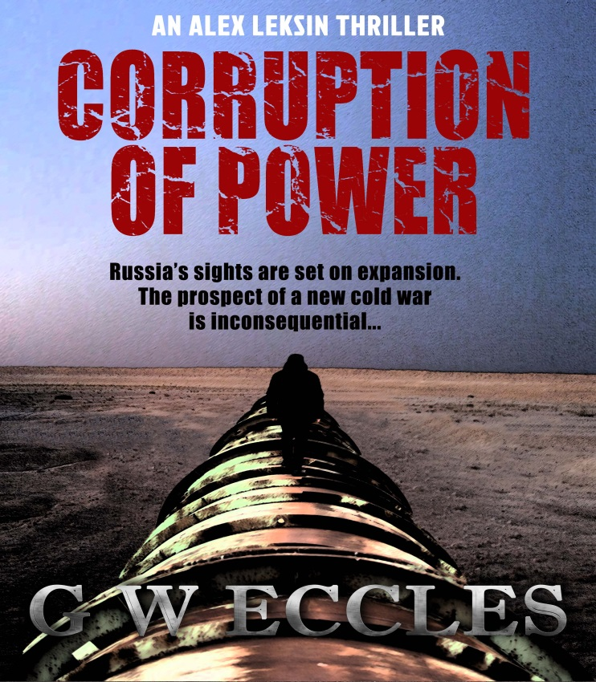  Contents:  - Recent Recognition & Awards for CoP  - Only in Russia  - Fact versus Fiction  - A Siberian Mining Town  - Interview Notes  - The Alex Leksin thrillers  - About the Author  - Follow the Author
Only in Russia . . . . .  According to Foreign Policy, Russians are gradually losing their right to foreign travel through a range of measures designed to limit their ability to leave the country freely. After the ‘sleeper spy’ leak in 2010, FSB employees were banned from travelling overseas. Next, these restrictions were extended to personnel at Internal Affairs, Defence, the Prison Service, the Prosecutors Office, police officers and firefighters (some 4 million people in total). Later the ban was applied to anyone with debts. Following the imposition of sanctions, citizens were advised not to go to the USA or any of the 112 nations with which that country had extradition treaties, and recent incidents in Egypt and Turkey (one of middle-class Russian’s most popular holiday destinations) have meant travel restrictions there too. Taken together, the measures seem aimed at reducing Russian citizens’ exposure to Western opinion while redirecting the massive cash flow of Russian tourism back into the country.  ******  When bailiffs near Perm visited a debtor’s apartment to take possession of his property, they found it all belonged to the man’s relatives. According to The Moscow Times, the only thing in his name was his cat. Estimating the cat’s value to be 1,500 roubles (approx $23), the bailiffs walked off with it in part settlement of the man’s debts.  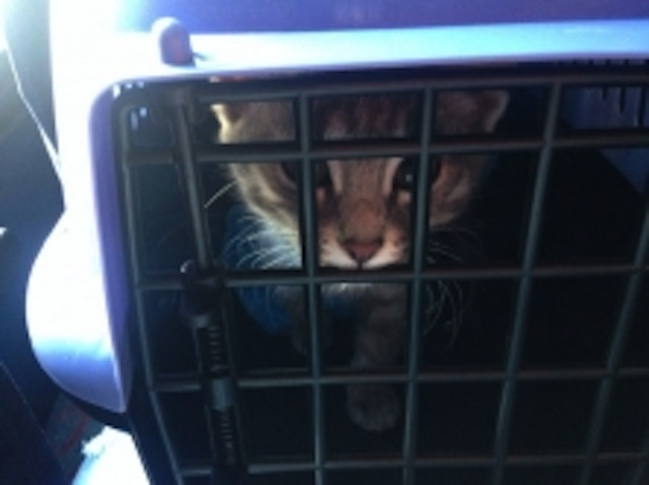  ******  Notwithstanding the Eurovision Song Contest is more about politics that the songs, actually singing about politics is forbidden. Even so, Ukraine has upset the Russians by choosing a song called 1944. It was in this year that Stalin forcibly deported the Crimean Tatars to Central Asia, where they were to stay many decades before being able to return. In the song (which you can hear by clicking HERE), Jamila (herself of Crimean Tatar extraction) tells the story of her great-grandmother being homeless and robbed of peace. Somewhat predictably the Russians have interpreted this as a swipe at Putin and his annexation of Crimea. |  | Analysis of the Panama Papers reveals that Russian cellist, Sergei Roldugin, an old friend of President Putin and godfather to his daughter, Maria, had ostensible control of assets worth at least $100 million. Amid allegations that he held this money for Putin’s family and cronies, Roldugin explained his so-called wealth was simply donations from rich businessmen to enable him to purchase expensive musical instruments for young Russians. “I am indeed rich,” he said, “I am rich with the talent of Russia.” This may of course be true, but it is sounding increasingly unlikely since The Organised Crime & Corruption Reporting Project has now discovered the cellist received money from the same offshore company used in the Magnitsky case, one of Russia’s largest ever tax frauds. Sergei Magnitsky was lawyer to Hermitage Capital Management until he discovered the fraud and was thrown in jail. He died there through mistreatment and lack of medical care. Bill Browder, Hermitage’s founder, has written an account of this scandalous affair in Red Notice.  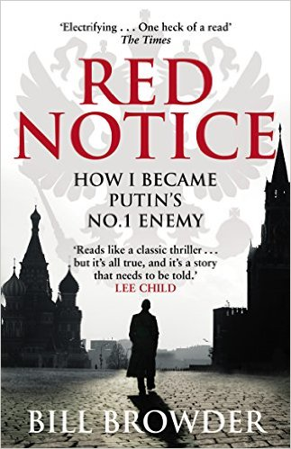  *******  The President of Turkmenistan has recently invited Qatar to participate in the construction of a transnational pipeline. The project, known as TAPI, will, if it proceeds, run a pipeline through Turkmenistan, Afghanistan and Pakistan down to the Indian Ocean. Its objective is to ensure the long-term supply of natural gas to the major markets of South-East Asia. Perhaps the idea came to the President after reading about a similar, albeit fictional, pipeline, in Corruption of Power?  ******  Will terrorism ensure a victory for Putin? The French parliament has recently voted in favour of lifting sanctions imposed on Russia in the wake of its Crimean land grab and subsequent shenanigans in Eastern Ukraine. France will now lobby the EU to do so. Its motivation appears to be a mixture of financial self-interest (eg they want to fulfil an order of two Mistral warships for Russia) and the need to fight terrorism. If the EU were to remove sanctions, French MPs argue, then an alliance could be formed with Russia to combat ISIS and find a solution in Syria. It all sounds like good news for Monsieur Putin.

Turning Russia into fiction  One of the techniques thriller writers use to add credibility to their story is to root the plot sufficiently in fact to give it an air of believability. This can be particularly important when, like the Alex Leksin thrillers, the book is set in Russia and former Soviet countries. Many extraordinary things happen there that are way outside the experience of the Westerner, and there is a risk therefore that the reader might consider the events on the page to be outside the realms of possibility. To avoid this, the author needs to set them in a context that makes them seem credible.  There are a number of ways of doing this, and they start with the question: what is the issue that gives rise to the problem that the hero has to tackle? If this problem is real and well-known to the reader, then the battle is half-won. When it clear that the background is true, it makes it easier for the author to carry his reader as the plot moves out of the realms of fact into fiction.  Set out below are some examples taken from the Leksin thrillers.  The Oligarch  Plot: The President wants to restore the massive Russian companies acquired for a song by the oligarchs in the 90s to State control. He turns to Leksin when one oligarch resists the order to relinquish one of the world’s largest mining conglomerates.  - Fact: In the mid-90s a group of oligarchs acquired ownership of many of Russia’s largest companies through the so-called loans-for-shares scheme. At the time the severely cash-strapped Yeltsin government was struggling to pay its State employees and pensioners. The oligarchs proposed to an ailing Yeltsin a scheme whereby they would lend the State money, taking as security shares in Russia’s largest companies (mainly, those involved in utilities, energy and natural resources). The conceit was that, by the time the loans became due, the government’s financial position would have improved, so the loans would be repaid. The reality – and fully appreciated by all parties at the time – was that Yeltsin would have no choice but to default and, therefore, ownership of the companies would pass to the oligarchs. This of course is what transpired. Despite the fact that the loans were for far less than the value of the companies, their ownership passed to the oligarchs.  - Fact: When Putin became President in 2000, his declared intention was to return these companies to State control. In the end, he realised the oligarchs were too powerful to take on en masse, so he did a deal: don’t plunder further State assets and support me, then you can keep what you’ve got. Initially he kept to his pledge, although he has picked away at individual oligarchs as they’ve fallen out of favour ever since. |  | - With the exceptions of Putin’s cronies, many of the oligarchs have had a troubled history with Putin. Those who tried to oppose him, such as Khodorkovsky or Berezovsky, were either imprisoned or forced into exile while their assets were stripped away under one guise or another. Others have been forced to give up control of their media companies, giving Putin control both of what the population is told and how events outside Russia are reported.  Corruption of Power  Plot: The President is intent on restoring his country to its former glory by regaining territory lost on the break-up of the Soviet Union. Certain that the West’s response to such action will be limited to economic sanctions, he determines to minimise their potential to cause damage by switching the markets for Russia’s massive energy deposits to the East. He turns to Leksin when the plan threatens to cause armed conflict along Russia’s southern border.  - Fact: There can be little doubt that Putin is determined to restore Russian power and would like to expand his influence and control to neighbouring territories. Events in Crimea and Eastern Ukraine stand testimony to this. Western analysts continually express concern about Putin’s intentions in the Baltic States. Most recently, Poland has asked for NATO troops to be posted on its Eastern border as a counter to potential Russian aggression.  - Fact: The West did not respond militarily to Russian aggression in Ukraine, but limited its response to economic sanctions.  - Fact: Russia is increasingly refocusing its economy towards the East. For some time Russia has been courting China, and this process appears to have taken on fresh impetus since the imposition of sanctions. Recently, Russia announced an agreement to build a pipeline to supply energy to China.  - Fact: Ever since he came to power, Putin has been concerned by what he regards as Russia’s soft underbelly. There has been constant unrest within the country’s southern regions (for example, Chechnya, Ingushetia and Dagestan). These places have become ready recruiting grounds for ISIS. In addition, Putin has watched with growing concern the gradual resurrection of the Taliban inside Afghanistan and their inexorable expansion towards the borders of former Soviet states such as Tajikistan, Uzbekistan and Turkmenistan.

A Siberian mining town  Norilsk – Fact  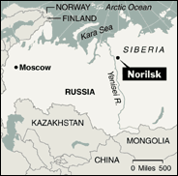  The town of Norilsk is located well within the Arctic Circle and has a population of 200,000 inhabitants. It exists to serve Norilsk Nickel, one of the world’s largest mining conglomerates responsible for a third of global nickel supplies and occupying a territory roughly equivalent to former Czechoslovakia.  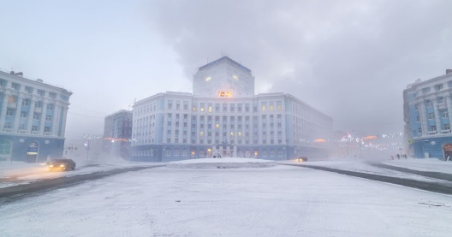  The settlement was established in 1935 as one of Stalin’s original gulags. Citizens who fell foul of his regime were shipped over the Northern Sea Route to Dudinka, the nearest port on the Yenisei River, and it was from here they were selected at random for the specific gulags where they would work (and, in many cases, die).  For eight months of the year, the area is encased in thick snow, with temperatures varying between -30C and -60C. During the two months of polar night, the population live in virtual darkness. Access to the town, which is prohibited to non-Russians without special permits, is by air or by sea, often in convoys led by a nuclear ice-breaker. A railway link from Eastern Russia that was once planned to make the shipment of prisoners to the region more efficient was cancelled after Stalin’s death. As a result, the town has been forced to become self-sufficient, having its own nuclear power station, one of the most modern hospitals in Russia, and the world’s most northerly cattle and pig farm. It is no surprise, therefore, that residents visiting other parts of Russia refer to such trips as ‘going to the mainland’.  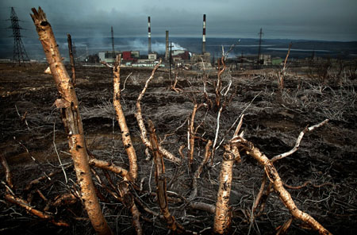 |  | Half-a-million prisoners took part in the construction and operation of the mine. Some 17,000 died through forced labour, starvation and intense cold. When the gulag system was finally abolished in 1956, many former prisoners stayed on as paid labourers and designed the ‘new town’ of Norilsk in the style of St Petersburg, the city from which many of them originally came.  The region is one of the most polluted places on earth. The smelters pump 2.5 million tonnes of sulphur into the air each year, and the almost permanent black cloud of pollution that hangs over the town is said to be visible with the naked eye from the Mir Space Station. This presumably accounts for an average life span among the company’s workforce of less than 45 years.  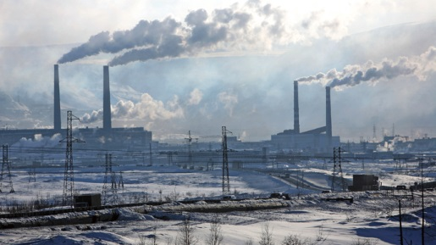  Tyndersk – Fiction  Tyndersk, the fictional mining town, in The Oligarch, was inspired by the actual town of Norilsk. In the excerpt that follows, Leksin gets his first glimpse of hell.  Turning onto the ring road, Leksin caught sight of the devastated landscape that enveloped the town and drew in his breath. Dense black smoke spouted from the narrow mouths of a smelter’s three tall funnel-shaped chimneys, spreading in a suffocating canopy thick as felt. Straight ahead, pylons and cables crossed the sky like enormous fishing nets hung up to dry. The cold metallic disc of the moon still hovered above an untidy heap of freight containers. Here and there wisps of stunted trees needled their way through the snow in strange, contorted patterns. A railway track meandered into the distance, undulating over the rugged terrain. Leksin shuddered: the monochrome, desolate scene seemed lifeless, reminding him of the haunting imagery of the Shevchenko urban landscape that hung on his study wall at home. No wonder the people here had short lives.  He joined the main road to Dostik, following the route of the railway track. The left side was bounded by thick pipes, more than a metre in diameter, raised off the ground by jagged concrete brackets and lagged with silvery asbestos fibre. On his right, piled between the road and the railway track, obsolete vehicles and equipment lay abandoned and rusting – torn sheets of metal and knotted cables, decaying wooden crates, ancient lorries with windowless cabs peeping out through the grimy snow.

Interview notes  I have continued to give a number of interviews, and extracts from those with Mercedes Fox, The Bandwagon and The Scary Review are set out below.  Give us an insight into your main character. What does he do that is so special?  The hero of both The Oligarch and Corruption of Power is Alex Leksin, an independent troubleshooter. He was born in London but of Russian descent. Although he had a traditional English education, he has always felt himself a bit of an outsider – not quite ‘English’ enough; yet when after a spell in the forensic unit at MI5 he moves to Moscow, this feeling of being an outsider continues – not quite ‘Russian’ enough.  He has a first class brain – ‘the best economics student I ever taught’, according to his Cambridge University professor, and an MBA from Harvard Business School – and he can take care of himself (a member of his university karate team). His MI5 training has taught him to break down problems into manageable units and tackle them methodically, but it is his intuition that singles him out. Time after time it is when he follows this that he finds the lead he seeks. His services are so much in demand that, by the time we meet him, he charges a flat, non-negotiable fee of one million euros, payable on success.  But Leksin is far from a perfect human being. He is constantly plagued by self-doubt, drives himself beyond endurance limits, and resorts to artificial stimulants to keep him going. While he is popular with his contemporaries, he has few real friends, and his relationships with women tend not to stay the course. In Russia he works regularly for President Karpev, a self-seeking, unscrupulous, ex-FSB bully, and while Leksin has no illusions about the man, he has no problems working for him.  Who is your favorite character in Corruption of Power?  Leksin is ‘my baby’, so he has to be my favorite. But after him comes Nikolai Koriakov, Leksin’s closest friend. Nikolai is the son of a former Soviet apparatchik and won a scholarship to study at Cambridge where he met Leksin. While Lekin went to Harvard and then gained experience with MI5, Nikolai returned to his homeland and worked his way up the political ladder. By the time we meet him, he is deputy minister at the Department of Overseas Development, one of the President’s rising stars, and the person responsible for first introducing Leksin and his specific talents to his boss.  Nikolai is eminently likeable – charming, fun, loves his food (especially chocolate), supportive and loyal. People are often misled by his easy manner and discount him – at their peril.  Who is your least favorite character in the book?  I am not sure whether it is right to describe her as ‘least favorite’ because, I have to admit, I understand her, but Nadia, the freelance terrorist, is definitely the most sinister character in the book. A ruthless, efficient and merciless operator who kills to order, her assignments are most often |  |  | instigated by the ‘authorities’. What makes her so disturbing is her detachment, the way she accepts her instructions without question and without regard to the victim. She has no moral compass. To her, it is just a job, like any other.  What are the themes you like to write about?  Both books I have written – the first, The Oligarch, and the new one, Corruption of Power – taken place in the former Soviet Union. The Oligarch is set in Moscow, Siberia and Ingushetia (Chechnya’s neighbour); Corruption of Power is set in Moscow, Tashkent in Uzbekistan, and throughout Turkmenistan. These are all areas I know well from my own experience.  The overriding theme in both cases is corruption – political corruption, business corruption, and corruption among individuals. The end all too often justifies the means: governments will risk conflict to achieve their objectives; dissenting voices are unacceptable, so if a critic cannot be persuaded to refrain, he is eliminated; terrorist incidents are manufactured to manipulate public opinion. In both my books I offer no judgements. It is often difficult to discern whether it is just the bad guys who are corrupt or whether the good guys are corrupt as well.  In my experience, this rings true of the region. In many cases, without dealing with people you know or suspect to be corrupt, it is impossible to do business. By refusing to sink to their level, you can seriously prejudice your own chances of success. Take the courts for example. In Turkmenistan when I was there, judicial decisions were regularly based on the size of the bribe the judge received. Local businessmen were happy to bribe, Western companies were generally not. No prizes for guessing which side normally won their case.  Finally, a few words for new writers. What obstacles can they expect and how best do they overcome them?  The key problem, as I see it, is that the publishing industry is biased against new writers. Over the last 20+ years there has been massive concentration in the sector, so the number of individual houses that might publish (or at least consider) a new writer’s work has severely diminished. Those that are left are risk-averse and prefer to rely on the cash cow of their existing bestseller writers. This makes it difficult for new entrants and deprives readers of loads of good books that never get the exposure a mainstream publisher brings.  How do new writers get around this? With great difficulty, I fear. Most, befuddled with frustration, take the self-publishing route. The self-publishing revolution has enabled writers to get their work out there, where before it would have been consigned to a bottom draw. Many writers have had considerable success in this way, although so far as I can see, this has been mainly confined to specific genres. The process is an uphill struggle for many authors who takes on total responsibility for publicising their book, a task for which they have no training and no promotional budget.
THE ALEX LEKSIN THRILLERS  Video trailer for Corruption of Power  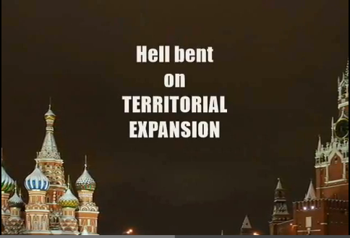  Click HERE to watch the video trailer  WHERE TO BUY CORRUPTION OF POWER  Published by Peach Publishing as a paperback and kindle e-book, and available from all global Amazon stores, including:  Amazon UK Amazon USA  Video trailer for The Oligarch  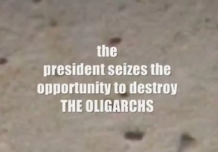  Click HERE to watch the video trailer  WHERE TO BUY THE OLIGARCH  Available from all global Amazon stores, including:  Amazon UK Amazon USA |  |  |  | About the author  In 1994, George Eccles left London to move to Russia and Central Asia during the tumultuous period that followed the breakup of the Soviet Union. His work involved extensive travel throughout Russia, Kazakhstan, Uzbekistan and Turkmenistan - often to places with restricted access to foreigners. During his time there, he advised a number of real-life oligarchs how best to take advantage of the opportunities that became available as regulation crumbled and government became increasingly corrupt.  His first thriller: The Oligarch, was awarded a Silver Medal both at the Global E-book Awards 2013 and at the Independent Publishers Book Awards 2013. His second novel, Corruption of Power, was published by Peach Publishing on 14 December 2015 and won a medal in the Best Mystery Thriller e-book category at the recent Independent Publishers Book Awards.  George is married and now lives with his wife – together with a cat called Lenin and a bulldog called Boris - in a hilltop village in the South of France.  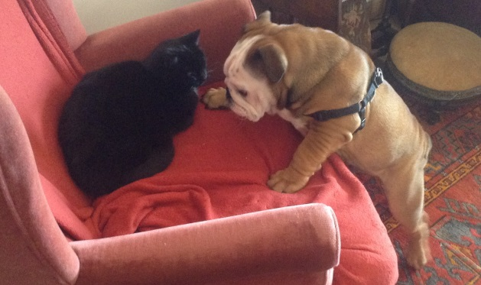  The author’s pets  Follow the author  Website and blog: http://www.gweccles.com  Twitter: @gweccles  Facebook: George Eccles  Corruption of Power: Facebook group  Goodreads: G W Eccles  Subscribe to the Mailing List  Write to the Author

